

*Meet us at Eureka Park #60611-14*

***So much more than a Solar Controller,   
a must for every solar water heater***

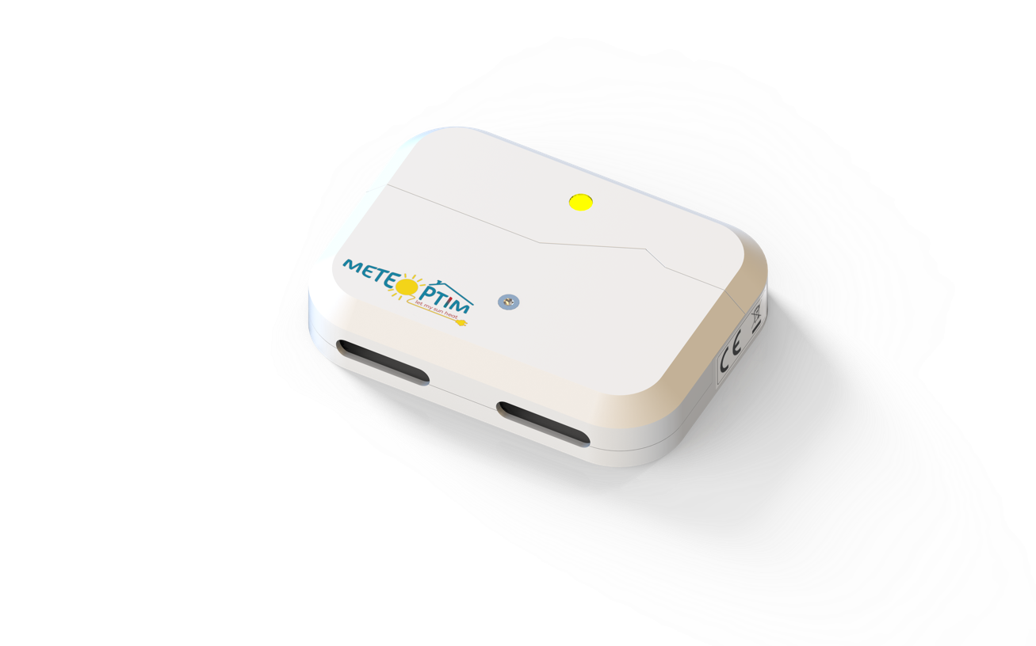

**The Meteoptim Box is the world's first and only solar controller that monitors solar installations and really optimizes the cost of domestic hot water.**

Every solar heater or hybrid solar installation needs a solar controller to run the solar pump when panels are warmer than the water tank. Most of them are also equipped with a **back-up electric resistance**, to ensure hot water in winter or in bad weather conditions.

******But today, there isn't any solution that runs this electric back-up only if really needed. So, one can start a beautiful sunny day with an unnecessarily hot water tank, that has been heated during the nightly off-peak hours. This is **ridiculous**: there was no need to use so much electricity during the night, and solar production is limited, as the water tank is already hot.

In addition, this back-up resistance often masks anomalies on the solar circuit, that are not detected by the end-user.

**Our solution activates this electric back-up only if really needed, and during the cheapest hours. Using AI and weather forecast, we anticipate both user's consumptions habits and up-coming solar production, which allow to decrease by an additional* 30% the need of purchased electricity, while ensuring the same level of comfort.**

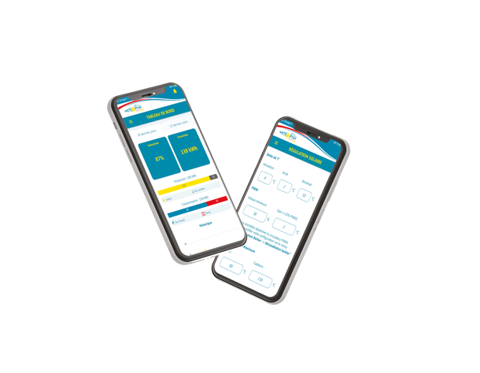Should solar production be inconsistent with actual weather conditions, a failure is directly notified to the user, which allows to call for repair and secures the **return on investment, reduced by 2 years** !

Our connected box is **self-learning**, **system agnostic**, and goes with a Mobile App, to configure and follow the performance of the solar.



We address the whole market of solar water heaters and hybrid panels (5 billion $/year), and we look for **solar product manufacturers** & **retailers** who want to enhance the attractivity of their solution with the Meteoptim solar controller.

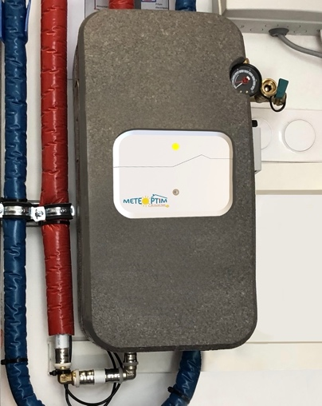



Gaétan MONARI

C E O

(+33) 6 30 61 86 75

gaetan.monari@meteoptim.fr





Damien BONNET

C T O

(+33) 6 77 54 51 34

damien.bonnet@meteoptim.fr

***www.meteoptim.com***

Pépinière #Cleantech - Technopôle de l’Arbois – 13100 Aix-en-Provence – FRANCE

*\* compared to a standard solar controller*